Associative Remote Viewing DREAM PROJECT
Katz, Debra; Smith, Nancy; Bulgatz, Michelle; Lane, James

Abstract
The present double-blind study is the first of its kind to utilize dreaming as a precognitive tool within an Associative Remote Viewing (ARV) protocol. A cohesive group of experienced remote viewers who varied in experience with intentional ESP precognitive dreaming practices took part in a year-long study that included 56 trials in which they attempted to have precognitive dreams that would enable them to produce descriptions and sketches that would match a photograph they would be shown at a future time. 5 out of 7 remote viewers turned dreamers were able to consistently produce dreams at will. Their transcripts were utilized for the purpose of making predictions and wagers on outcomes of sporting events. If we focus on 17 hits out of 28 predictions, a binomial test, finds a P-value of p=.07 one-tailed for the proportion of hits. Although this is not significantly better than chance, overall monetary winnings increased by 400 percent. Further, one individual dreamer had a 72 percent correct hit rate based on 13 hits and 4 misses with 20 passes while another had 16 hits and 9 misses.
KEYWORDS: Associative Remote Viewing, Precognition, DREAM ESP, remote viewing, precognitive dreaming.

Introduction
Background
Remote Viewers are those who utilize their clairvoyance and other intuitive based perceptual abilities in a systematic way to produce a written and pictorial transcript of an assigned “target” (Swann, 1993). Associative Remote Viewing (ARV) is a specific and rather complex double blinded set of procedures used for the purpose of bypassing the typical pitfalls of having remote viewers tune into potential outcomes of a future event (such as a horserace, sporting event, or stock market fluctuation) in which the possible winning options are too familiar or too similar to each other for judges to determine which outcome is being described (Katz & Bulgatz, 2013). ARV involves random pairing of the possible outcomes of an event with unrelated photographs or objects that a remote viewer is asked to describe in advance of the event, so that a prediction can be made by whom ever is managing the ARV trial.
Associative Remote Viewing has resulted in the substantial financial gain by various researchers over the past 4 decades. Harary & Targ (1982) earned $100,000 by forecasting changes in closing prices of the silver futures market, with the aid of 9 ARV trials, however in a follow up experiment they had nine consecutive losses which researchers attributed to an increase in daily ARV trials per viewer, rendering receiving feedback for one trial impossible prior to beginning another (Targ 2012, Houck 1986). In 1985, Targ and his co-researcher repeated their “real world applications experiment” by using a “redundancy protocol” in which viewers participated in only one ARV trial per day. Also, passes were called if the remote viewers both “accurately described photos in discrepant directions”, and if a 4 was not reached on a 0-7 rating scale with a two point spread in between scores. 12 of 18 trials resulted in predictions and from these 7 forecasts were recorded as trades even though no monies were wagered. Six of these were correct (Targ, Kantra, Brown, & Weigand (1995)).
Harold Puthoff (1984) successfully conducted twenty-one of thirty trades with the help of seven select remote viewers, yielding profits of $25,000. Greg Kolodziejzyk, acting as a single operator over a 13 year period, utilized a unique computer-based modified approach to the ARV protocol which combined remote viewing, logic, and knowledge of the stock market, yielding a profit of $146,587.30. Most recently Smith, Laham, and Moddell (2004) conducted a series of only 7 ARV trials with university students turned novice remote viewers, earning apx $16,000, by wagering substantial amounts of $10,000 at a time.
Associate Remote Viewing has also resulted in the loss of significant investment. IN 2000, experienced remote viewers using a forced choice type ARV protocol (most ARV projects involve open choice tasks) completed 100 initial trials, which were not wagered on, resulted in a stunning 99.8 hit rate. However, once investments were made across 3,500 trials, results evened out around chance levels (Rosenblatt, 2000). Most recently, 60 remote viewers contributed 177 predictions resulting in 152 FOREX executed trades, resulting in a loss of $52,186. (Katz, Grgić, & Fendley, 2018).
Associative remote viewing in the last couple decades has been the focus of formal research projects (Targ et al, 1995). However, a greater number of investigations have been conducted by remote viewing enthusiasts who operate outside of academia or formal research venues. Even so, these investigations include double-blinding procedures and careful protocols, which qualifies them as exploratory or informal research projects (Bierman, 2004; Katz & Bulgatz, 2013, 2016). While some work independently as did Kolodziejzyk in 2015, the majority operate in groups, working at a distance with the assistance of web based communication and delivery technologies (Rosenblatt, Knowles, Poquiz, 2015).
One such group is known as the Sublime Remote Viewing Group, which formed at a conference sponsored by the Applied Precognition Project and began its first set of informal trials in June, 2012. The group consists of 5 experienced remote viewers and a manager that have been working together on various informal, applied and exploratory projects, many involving the use of an associative remote viewing (ARV) protocol although they have also worked on criminal investigations.
After hearing Dale Graff, a physicist and former director of Project Stargate (one of the government programs that investigated remote viewing phenomena), at an IRVA conference, describe a decade-long project he and Patricia Cyrus conducted involving the use of dreaming for describing future newspaper articles (2016), the Sublime group decided they would substitute dreaming for remote viewing within an Associative Remote Viewing Protocol. This decision was strengthened after reviewing several ESP dream-related meta-analyses performed by Krippner (1993), Utts (1988) and Sherwood & Roe (2003), and further encouraged by preliminary findings of a new meta-study that examined all experimental dream-ESP research for the period 1966 to 2016 (Storm et al, 2017). These studies have all concluded that psi was in fact demonstrated, but differed in conclusions about whether dream studies within the laboratory setting (with the use of REM monitoring) were more effective (Sherwood & Roe, 2003) than those conducted outside of it, or if they were equal as Storm et al. determined (2017).
The present double-blind study is the first of its kind to utilize dreaming as a precognitive tool within an Associative Remote Viewing (ARV) protocol. A cohesive group of experienced remote viewer, who varied in experience with intentional ESP precognitive dreaming practices, took part in a year-long study that included 50 trials for the prediction of sports outcomes and wagering.

Methods
Overall objective, hypothesis, approach
This project was designed as a hybrid operational/research project. Attempts would be made to duplicate the group’s typical “real life” ARV operating procedures (which has been consistent across other applied projects under the umbrella of The Applied Precognition Project) while adhering to sound scientific principles and practices. The latter included submitting the proposal to the Rhine Research Institute’s review panel; registering the proposal with a science registry;
maintaining double blinding of both dreamer and manager/judge to the content of the target photographs; and using computerized randomization procedures.
The overall goal of the project was for the group manager to make at least 50 predictions that would be wagered on in a systematic way. Statistical results, including both the hit/miss ratio (hit-rates) and P values would be calculated for the aggregate groups stats as well as for individual viewers. Actual financial loss or gain would be calculated for the overall group wager.
It was predetermined that only trials resulting in predictions would be calculated into the overall statistics beyond tracking how many trials resulted in predictions vs. passes.
Per past informal Sublime group projects involving remote viewing, it was reasonable to expect that in order to reach 40 wagerable predictions, 50 dream trials would need to take place. The project’s designers debated as to whether to set the goal of continuing indefinitely with the project until 40 such predictions could be reached, but felt that having an unknown completion date exceeding one year’s time (as only one trial would be attempted per week to accommodate the dreamers preferences) would put too much strain on the participants and therefore capped the total of number of trials at 50. Each prediction would be for an “over-under” outcome of a particular sporting event (i.e. baseball game), which is a common type of bet offered in casinos, where both teams scores are combined to form the over/under score which the casino sets a betting line at). Each prediction would result in an outcome of a “hit” or “miss”. It was anticipated that with 40 predictions, a total of 26 hits (65% hits) would yield a significant one-tailed test (p = .04) using a binomial test and assuming that chance guessing would yield 50% hits.

The static photo pairs (which would be associated with potential binary outcomes within a single event) were selected by an independent team of experienced ARV project managers ((Jon Knowles, Alexis Poquiz, and Igor Grgic) experienced in selecting photo pairs in terms of orthogonality (they must be different from each other in every respect), and interest level. The pairs were then encrypted using a computer program that were randomized and sent only to the project manager, Nancy Smith, who did not access the photo set until after all transcripts were submitted per trial.
In order to maintain proper separation of roles, once the experimental phase began, co-researchers Katz and Bulgatz acted only as dreamers until all trials were complete, giving all authority and management responsibilities to co-researcher Smith. At no time did they have access to the any of the photos, prior to being sent their feedback photo at the designated time. Further, they have never and will never have access to the unactualized (aka photos attached to non winning outcome) from the sets
Aggregate Group Approach
Due to feasibility issues; a desire to maintain standard operating procedures; to capitalize on the groups cohesiveness which traditionally including sharing transcripts following completion of a trial; and to mitigate the likelihood that some of the viewers might not be able to dream at will or remember their dream for each trial, it was decided that all group members would participate in the same trials and that their transcripts would be assessed using a group aggregate approach. This meant that the manager/judge would utilize all available transcripts to make a single prediction and wager per trial, (although as noted above, individual scores leading to what could be individual predictions would be tracked and evaluated in the final analysis).
Furthermore, all viewers would operate from the same photo sets, receiving the same photo feedback. This would minimize the likelihood of the dreamers “peaking” at each other’s feedback photo when engaged in their psi related task, which has been an issue in the past when the team members each were assigned different photo pairs. While decisions such as this have been criticized by some parapsychologists concerned with a stacking effect, according to Brier (1970), who first discussed the stacking effect in relation to forced choice task type experiments involving multiple trials in one setting (such as when a deck of 52 cards is being “guessed” at), there are valid reasons to sometimes assign all participants the same target types, in the same order, and this should never disqualify a design as being flawed (Thouless and Brier, 1970).
Participants
The entire sublime group of remote viewers and one manager/raters participated in the experiment. Dale Graff was recruited to the team and served as both a dreamer and a dream advisor.
There were 4 men and 2 women who were between 48 and 75 years old. All viewers were trained and experienced in remote viewing. 4 have been trained in Controlled Remote Viewing (Buchanan, 2003), and 3 had received training in extended remote viewing methodologies (Moorehouse, 1996). Three also have training in other non RV clairvoyant methodologies (Katz, 2004; Katz, 2009). They all had completed at least 50 RV sessions: 2 had completed between 100 and 500 sessions; 3 had completed between 500 to over 1000 sessions. Most reported meditating at least twice a week and some on a daily basis. As far as dreaming: half reported sometimes remembering dreams, three reported frequently and one reported very rarely. They all believed it was possible to dream through intentional precognition, and yet they also said that precognition was not the main reason they believed they dream. Graff was the only participant who had experience with intentional dreaming of a future feedback photo although all believed it was possible and reported having had at least one or more spontaneous, unintentional precognitive dreams in the past.
Nancy Smith has been sublime’s manager for four years. She is a trained remote viewer, is a former Monroe Institute facilitator and IRVA board member and longtime educator/teacher. For this project, as in the past, she was responsible for all phases of project and management including choosing events, judging, communicating with participants, tracking data, etc.
Each dreamer participated and operated from their own homes as is their typical procedure given they live in different parts of the United States. The exception to this is one of the dreamers, Sam Smith, is husband of and lives with the group manager.
Procedures and Timing
Timing and ordering of specific tasks is critical within an ARV protocol. Trials were carried out once a week so as not to overwhelm the viewers or judges, with pre-planned breaks in between sets of 10 trials and occasionally pauses when the project manager, Smith, required them.
Tasking the dreamers per trial
Smith sent out emails of the upcoming dream task to each participant a few days prior to the chosen event. The email reminder contained the target number that would be paired with the feedback photo for each particular event/trial. Target numbers were made up of the date the feedback would be given, which was also the deadline for submission of transcripts.. This email also included a brief reminder to dream on that Saturday evening (or Friday if that was more convenient) and to email back their written transcripts containing words and sketches by the deadline, which was typically 9:00 am CST on that Sunday morning.
Choosing an Event Protocol and Pairing it with a photo Set
One week prior to the event, the group manager would go to the ESPN website, click on the game schedule under a specific category (i.e. Basketball, Baseball or Football), and always select the 3rd game listed to be played on the upcoming Sunday. In the example below the selected game would be MLB Los Angeles @ Boston.
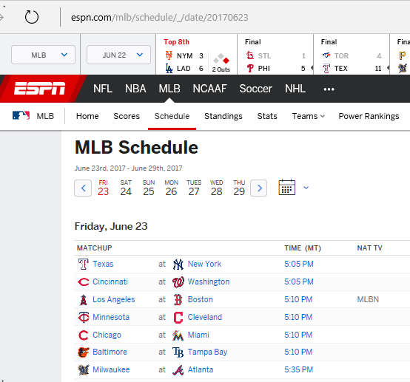
(figure 1)
Next the group manager would look up and record the Over/Under spread, published on both the ESPN website and 5 Dimes website, for that particular game.
The spread is a common wager that is set up a sportsbook’s odds makers as to what the combined points of the two teams will be when the game is over. This includes a “line” so that bets can be made predicting whether or not the actual number will be higher or lower than the set number (Williams & Siegel, 2014)
In the example below, the Over/Under (O/U) line is 8.5. (Which is what the statisticians/bookies are predicting will be according to their extensive knowledge of the particular teams playing and game itself). Therefore the public who is wagering needs to predict whether the total point will be Over or Under 8.5 points. For the current project, the Over/Under predictions were chosen instead of the winning team predictions because the O/U has been found to be less emotionally volatile for Sublimes team members, some who are avid sports fans.

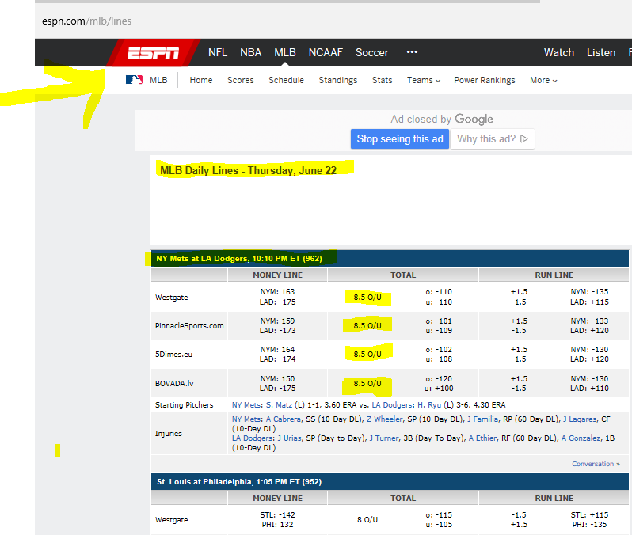
(figure 2)
Pairing photo with Binary Event Possible Outcomes
At this time a photo pairing was selected from a list of encrypted sets and paired in her master document with the target number for the upcoming event. The sets, were already labeled (A) and (B). Photo A was paired with the “over” outcome, and Photo B was paired with the “under” outcome.
Dreamers protocol
The dreamers specifically followed protocols offered by Dale Graff to increase the likelihood of dreaming and recall (Graff, 1998, 2000, 2007; Graff & Cyrus, 2016)
2016). They were instructed to purchase a dream journal of their choice. On the Saturday evening, they would write out an intention statement on a page in their journal originally suggested to them by Bulgatz, a hypnotherapist, with the freedom to add to it as they saw fit (Some dreamers found it useful to add in a congratulatory message about what a great job they were about to do while conjuring up enthusiastic emotions over this imagined success). Dreamers were advised to write down the target number in their journals or papers, as they have all been trained to do at the start of the remote viewing session, except instead of proceeding with a remote viewing session, they would go directly to sleep. This intention/tasking included telling their subconscious to have the needed information appear during the final dream of the evening, prior to waking, so that it could easily be recalled and distinguished from the earlier dreams of the night. It included the intention to have visual information come into the dream that could easily be converted to a sketch upon awakening. Dreamers were instructed to record all dream impressions of the evening without delay upon awakening. If they awakened prior to having a dream that could be recalled they needed to either try to go back to sleep if time allowed, or to simply send an email to Smith with the words “no dream”. They were advised that it was never a problem if they couldn’t dream and were instructed and reminded to never supplement the dream with attempts at retrieving information psychically while awake.
All dreamers were required to turn in their transcripts or report “no dream”. by 9 am CST time.
At this point Smith would have a narrow window of time to judge the photo, register the prediction, and place a wager if there was a viable prediction.
Judging and Prediction Criteria
Smith would start with one dreamer’s transcript and compare this to one photo in the set, (photo A now paired with the option of “over” for the over/under wager). Using the 7 point CR SRI scale (Targ et al, 1995) Smith would assign it a CR score before even looking at the next photo paired with the option of “under”. Once she had assigned CR scores to both photos she would evaluate the spread in between the sum of CR scores for both photos. According to informal guidelines established by several project managers who participated in the Applied Precognition Projects Conferences (including Smith and other researchers here), and in alignment with Targ et al’s 1995 findings, it is generally accepted as good practice to only proceed with a prediction is there is at least a 2 point “spread” in between the two scores or sums of two scores.
Wagering protocol
If a prediction was issued, Smith would then return to the 5 Dimes online Betting Website (www.5Dimes.eu), go to her account, and place a wager based on the prediction per the following wagering instructions:
“Totals - When you bet on totals, you are betting on whether the total points scored in the game will be higher or lower than the posted total. Totals Payoffs - For football and basketball the payoff for a winner is $100 for every $110 wagered unless otherwise noted. It is customary when making a bet that you put up the juice as part of your wager. Therefore, $110 will be wagered if you specify a $100 total bet. For baseball totals, the total points seldom move. Instead, applying a money line to the total creates line moves. Therefore, your payoff will depend on the money line at the time of the wager”
(https://www.5dimes.eu/sb_wagertypes.html)
While Smith typically wagered $110 on each prediction, there were two occasions when there was a problem with timing or her internet connection, and she wasn’t able to place a wager in time. If a pass was called instead of a prediction, no wager would be made.
Sharing the Prediction
Smith next than sent an email out to some of the participants who desired to receive these, informing them of the prediction or pass and revealing which sporting event the prediction was for.
Feedback
Within an ARV protocol, focusing on the feedback photo by the remote viewer or dreamer is seen as critical as it is only this photo that will be paired with the actual outcome. Focusing on the other photos in the set (whether via psychic perception or at a later point via regular perception as in projects allowing for self judging) can and often does lead to lead to describing the wrong photo, which then can lead to a “miss” and loss of wagers. Due to these potential retro-causal hazards, in order to close the “feedback loop” it is critical that the dreamers receive their feedback photo in a timely manner and actually do what Rosenblatt (Rosenblatt, Knowles, Poquiz, 2016) refers to as a Feedback session - time spent by a remote viewer closely comparing his/her earlier transcript and impressions/experiences had with the feedback photo. This involves looking at each word and sketch in a transcript and evaluating whether it was correct or not; trying to understand what worked and what didn’t; and making some notes to share with the project manager. For our project, dreamers were asked to send a short, informal email back to Smith sharing their thoughts so that she could ensure they had in fact spent time engaging with their feedback photo and also as a debriefing, stress relieving measure.
Occasionally, a day or two following completion of the trial, Smith would put together a compilation of parts of the viewers transcripts that had matched the feedback photo that would be sent to all dreamers in order to boost moral and group cohesiveness, such as the one below:
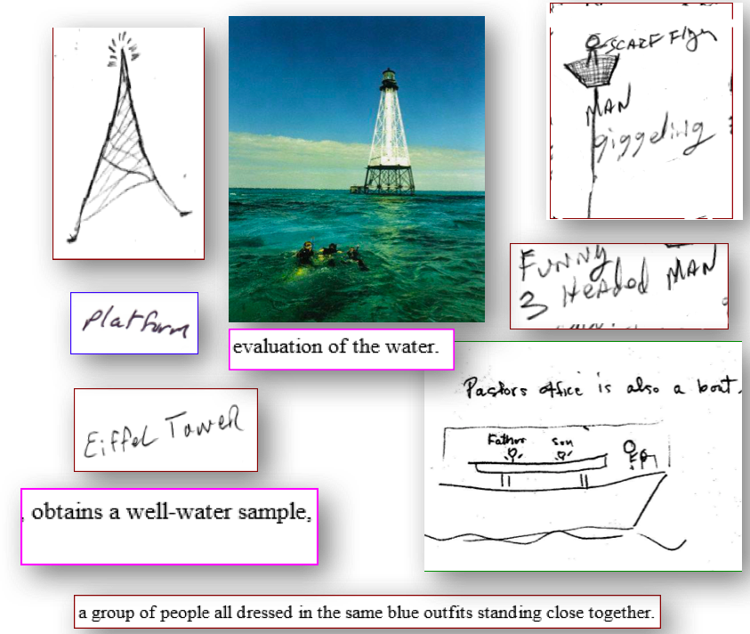
(Figure 3)

RESULTS
Aggregate Group Earnings
A total of $100 was invested. A total of $500 was won. Therefore a profit of $400 was made.
Once could postulate therefore that had a more ambitious wage been made of $1000 per bet, a profit of $4000 could have been made. Had $10,000 been placed per bet, a profit of $40,000 could have been made.
Aggregate Group totals for 56 trials
If we focus on 17 hits out of 28 predictions, a binomial test, assuming chance guessing, finds a P-value of p=.07 one-tailed for the proportion of hits. Although this not significantly better than chance, it is consistent with the overall monetary winnings.
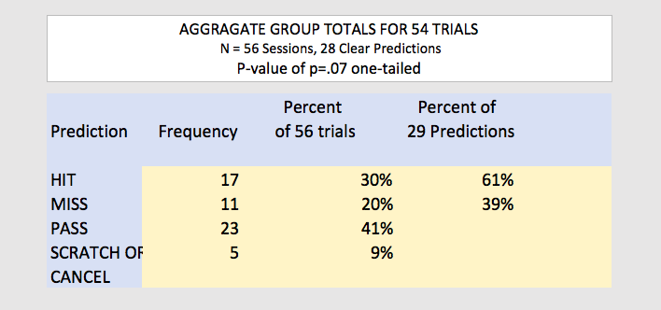
(Figure 4)

Individual Dreamer Totals
A total of dream transcripts were provided by the 6 dreamer for 56 session trials. (Dreamer “CG” left the project after the first 10 trials, stating his personal life was not conducive to dreaming. Dreamer “MR” participated only sporadically and it is unknown whether this was because he was not able to dream or did not attempt to do so).
The next tables shows the results for all 56 session trials, as counts or frequencies and as percentages for that individual, along with hit/miss rate and percentages for only wagerable predictions.
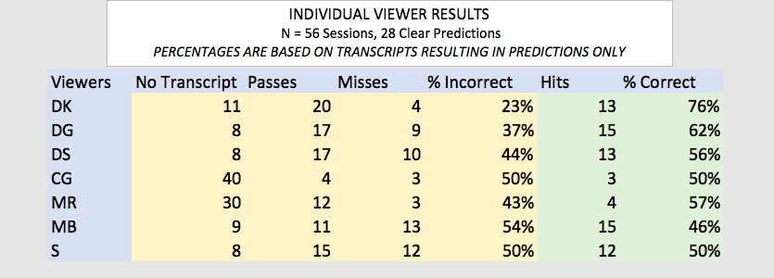

(Figure 5)

A simulation on monies for Individual Dreamers
A simulation on monies that could have been earned had the project design called for wagering on individual dreamers only. Dr. James Lane, the project’s statistician, calculated the money made based on the individual viewer’s prediction who had a 72 percent correct hit rate based on 13 hits and 4 misses with 20 passes. He calculated that if $110 was risked on each bet to make a $100 win, or a loss of $110, that “individual performances would have been quite profitable, growing the investment to $860”. One could then postulate that if $1000 had been invested, $8,600 would have been earned. If $10,000 per game had been invested, $86,000 would have been earned.
Not so Confident with the SRI/TARG 7 point Confidence Rating Scale
A tally of CR scores was performed that were given to both photos in the judging sets in order to gain understanding of whether the 7 point scale worked as intended which would have been matching higher scores (3.5 or higher) with the photo attached to the winning outcome, and lower scores connected with the unactualized outcome. Results are summarized in the table below. It was calculated that 331 CR scores fell between 3.5 and 6.5 on a 7 point scale. A CR Score of 3 is defined as “a mixture of correct and incorrect elements, but enough of the former to indicate the viewer has made contact with the target”. Of these, 179 resulted in hits and 152 resulted in misses. An analysis of the all CR scores for both photos in the sets revealed that 103 CR scores were 5 or higher. Of these, 62 resulted in hits and 41 resulted in misses. According to the scale, “scores of 5 or higher should have “Good Correspondence with unambiguous unique, matchable elements, but some incorrect information” Per application of the 7 point SRI CR rating scale, scores of 6 should have “good correspondence with unambiguous unique matchable elements, but some incorrect information”. An analysis of all the CR scores for both photos in the judging sets revealed that only 12 transcripts resulted in CR scores of 6 or more. Of these 12, 10 resulted in hits and only one in a miss. Scores of 5.5-5.75 resulted in an equal number of hits and scores of 4 and below were also fairly close. There were more scores of 5 that resulted in hits then misses but there were still 29 leading to misses.
It therefore appears that scores of 6 or greater were good indicators of hits.
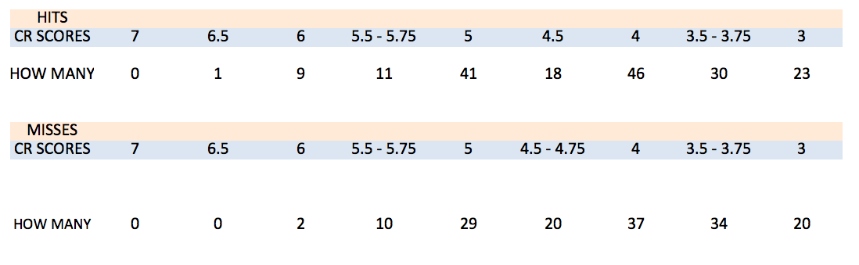
(Figure 6)

Discussion
This project was initiated with a few questions in mind. Can dreaming replace remote viewing in an Associative Remote Viewing protocol? Can experienced remote viewers, most new to intentional precognitive dreaming, operating independently from their own homes, without the aid of a REM monitoring, consistently produce transcripts in verbal and pictorial form matching a future feedback photo, on par with those created during a conscious remote viewing session? And would it be possible to both earn a profit and to achieve statistical significance over the course of 50 dream trials?
The answers to the first two questions is “yes”, considering the number of descriptive transcripts that were consistently turned in from the start of the project, with little prompting beyond email correspondence or incentives (beyond wanting to contribute to the goals of the group) over a one year period by most of the dreamers. Of 392 total transcripts, possible to turn in across 56 trials, 235 were turned in by the seven viewers collectively. Three dreamers submitted 42 dreams out of 50, One submitted 41 dreams, and another submitted 38 occasions. The bulk of missing transcripts came from two viewers (40 and 30), one who dropped out after the first 10 trials due to being in a place in his life where dreaming wasn’t practical, the other who participated sporadically.
Dreamers were told to not try to dream if they were too busy or stressed, so lack of turning in a dream was not necessarily indicative of an inability to dream on demand but according to their post experiment survey and interview responses, often due to disrupted sleep cycles due to staying up too late, traveling, house guests, excessive business and stress. In ongoing notes and followup surveys, dreamers expressed that they did not feel they had a problem with going to sleep on schedule and failing to have a dream. Three of the participants new to this type of dreaming task expressed being pleasantly surprised that they were able to dream on demand. Dreamer “A” reported at least three times where she had woken up within an hour of the deadline without having had a dream, and then told herself (and her family) she had to go back to sleep to retrieve a dream and was able to do so in time to turn in a transcript. On one occasion this was accomplished within 30 minutes of the deadline, producing a transcript resulting in a hit.
In response to the third question regarding could a profit be reached via an Associate Dreaming Protocol, the answer is also “yes”. While $400 is a modest number as far as earnings go, one has to take into account the very modest amounts of $110 that were wagered (in comparison to past ARV projects by other researchers where sometime individual wagers were as much $10,000). Future project therefore might consider wagering higher amounts. Also given a few individual dreamers stats were higher than the groups as a whole, with one dreamer’s hit/miss ratios as high as 72 percent, future projects might incorporate using select individual dreamers vs. a group aggregate approach with higher bets as well.
In terms of the fourth question, could statistical significance be reached? The answer is “not this time”. As mentioned earlier, in order to have done this we would have had to have made 40 viable predictions instead of the 29 that were made within the pre-established number of 50 trials. Therefore, one major adjustment to the protocol we’d suggest would be having a set number of predictions rather than a set number of trials.
We’d further recommend adjustments to how predictions are made in relation to scoring, if a 7 point Confidence Ranking scale is continued to be utilized. Close to half of the transcripts earned a 3.5 to 6.5 CR score. This would be seen as desirable if it wasn’t for the fact that many of the higher scores resulted in predictions made to the incorrect photo-option pairing, resulting in 10 misses out of 29 predictions (when the higher scores were mostly pointing to the same option) and to many of the passes (when the higher scores were split amongst options).
The reason for having so many high scores pertaining to the wrong photo can not be deduced from our data. We suspect it is a mixture of extra content being shared as part of dreams that were not relevant that could have coincidentally matched the wrong photo in the set, or that could have matched the wrong photo due to displacement, as in psi was functioning but toward the wrong target (Brown, 2006). Two close a similarity between judging photos (even though carefully selected) and judging decisions (albeit from a very experienced judge) of course could have entered into the picture as well as could have too generous scoring or predicting.
Due to our findings that more transcripts judged at a 4.5 CR score would have resulted in misses then with hits if wagered upon individually, we recommend that the threshold for which a prediction can be made when applying the SRI/Targ 7 point scale to ARV DREAM Trails be raised from the currently established 3.5 CR score to that of a 6 CR score. This is significantly higher than a score of 4 or higher suggested Targ et al in their 1995 ARV study, as they may have felt a 4 was sufficient due to differences in judging styles, in targets compositions (they used real objects) or in factors specific to for remote viewing as opposed to dreaming.
There is an expression amongst applied “precogers” which is “passes are an ARV applied project manager’s best friend”. It is felt that future projects should make more use of these more. This has been proposed by Joe McMoneagle and Ed May (2016) who using what they refer to as “figure of merit” (FOM) scores rather than the SRI scale currently, suggest that if the stakes are quite high and those running a project want to make sure they have only hits, the ratio between correct content towards one photo and incorrect content between another should be set at 90/10 percent – which would correspond approximately with a score of 6 or higher to 0 on a Targ Scale.
If the threshold was set higher, however, as noted above, it would be imperative to adjust the experimental design by swapping out a set number of total trials with a set number of predictions to be reached.
Another suggestion would be to eliminate the recently emerging habit by applied ARV project managers/judges (as was the case in this project) to assign half points or other percentages to the 0 -7 scale (i.e., 4.5; 5.75). This would force the judge to make a more concrete decision in one direction or another. Half scores were not included by the originators of the 7 point scale and there is no precedence to suggest they add anything to a the judging procedure, except indicating where the judge was conflicted. (in fact it may not be a bad idea to set as a general rule if the judge can’t decide which way to go to always go down to the lower score if an overall conservative judging approach is going to be undertaken.
Further, while the project manager stuck with the rule of having a two point spread between the total sums of CR scores for each photo, it appears that sometimes predictions were called where there was not a two point difference between individual viewers scores (i.e., Viewer A has a CR score of 5 for one photo with Viewer B having a 5 for the other). For this project, as with most applied ARV projects, there was not a hard and fast rule of how to deal with situations where one or more dreamers have the same or close scores for both photos, or when one team member has a high score for one side and another team member or two has a high score for the other side.
The question of should this always result in an instant pass (as suggested by Targ et all in their 1995 redundancy experiment) essentially throwing out all scores for the entire trial) or should the conflicting scores just cancel themselves out and therefore be ignored for that trial, with the other participants scores being considered only is a big one that seems to need to be worked out. For this project, a mixture of the above prediction approaches seems to have been applied. One of the present authors is currently in the process of exploring predictions and judging in a separate project underway (Grigc, Katz, Tressoldi, 2018) however at this time, the only recommendation to deal with these types of conflicting scores would be to call more passes. Had this been done in this project it would have resulted in less misses, but it also would have resulted in less hits. How much room the judge should have for his/her own intuition, knowledge of viewers/dreamers, etc., should also be discussed.
One factor that may have had an influence was that half the participants were receiving information revealing both the prediction and the particular event prior to feedback. Our group was too small to say definitively whether or not this made a difference. Despite several attempts to survey participants, some of those receiving the predictions did not formally track or report per the project’s guidelines their behaviors in relation to receiving the predictions. Therefore whether or not they even paid attention to predictions, whether or not they watched the televised games, or if they ever even personally wagered can not be assessed. Based on recent results from another study that utilized ARV for predicting the 2016 presidential election (Katz, Bulgatz, 2016) in which results indicated viewer’s may have been impacted by exposure to a wrong prediction, and due to lack of control over viewers behavior in relation to the predictions, we’d recommend removing this unnecessary variable from an already complex protocol for all future projects. This however will mean moving further away from a friendly, fun, applied approach to ARV, and closer to a more sterile, research oriented approach. Still, most of Sublimes participants acknowledged they would be ok with this moving forward.
We also would recommend that for future projects (whether ours or other researchers) that the project manager teams up with another judge or judges who could provide additional support, and help provide checks and balances to minimize potential biases towards one of the photos in the pairs; towards certain content within a viewer’s transcript; or towards one of the dreamer over another. This would be especially needed if a protocol is adjusted to allow for more passes, extending the completion time by possibly several months to achieve an adequate sample size.

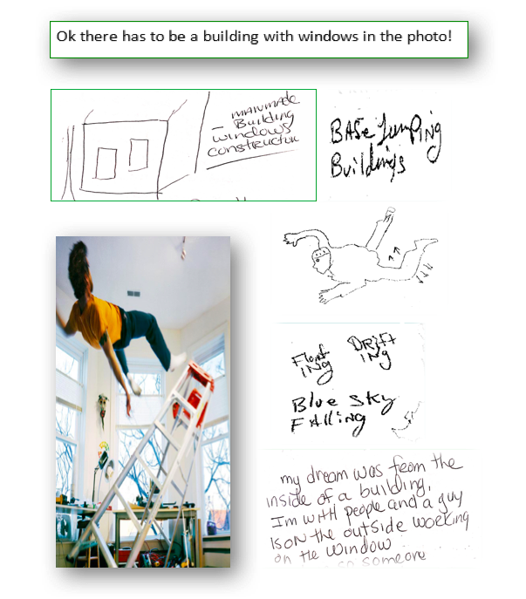
(Exhibit A)
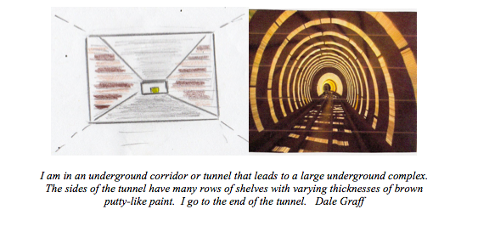
(Exhibit B)
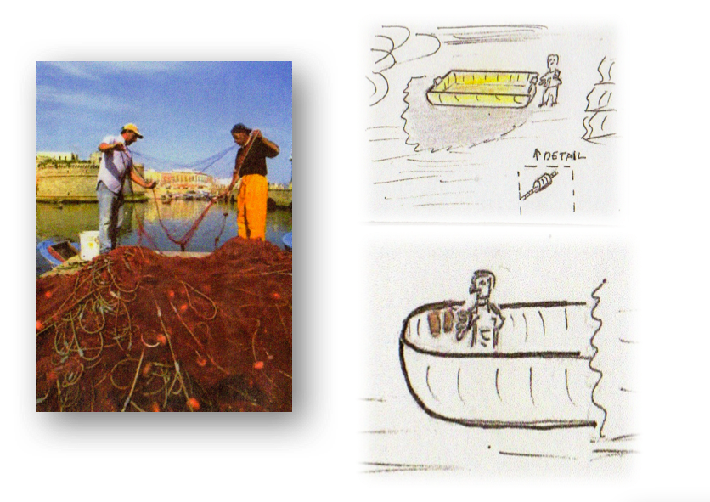
(Exhibit C)
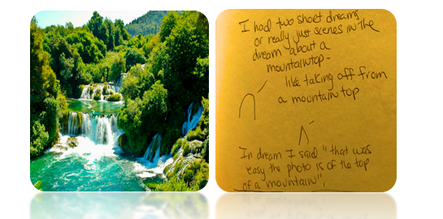
(Exhibit D)
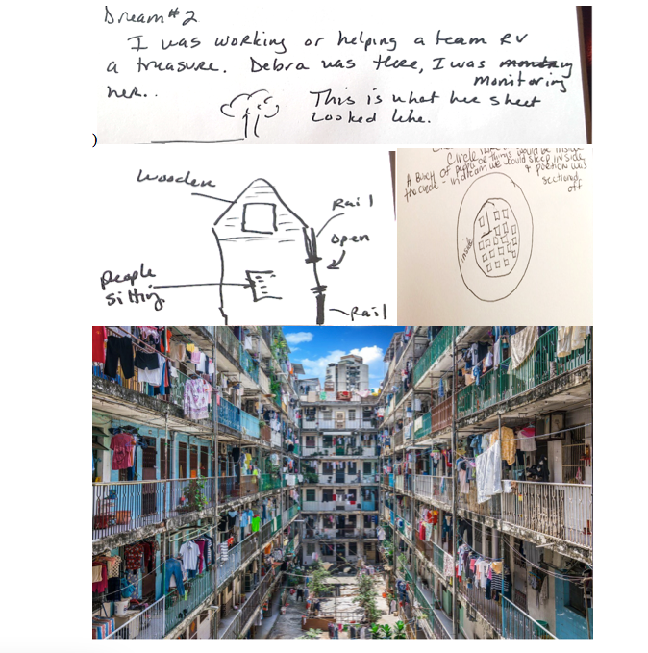
(Exhibit E)

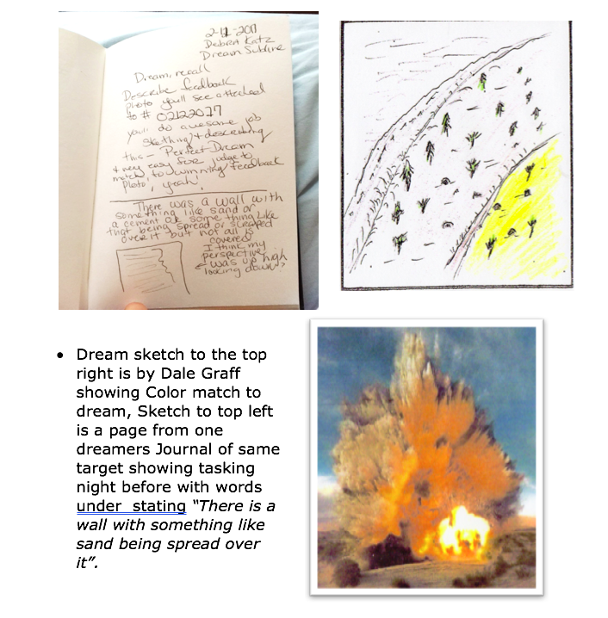
(Exhibit F)

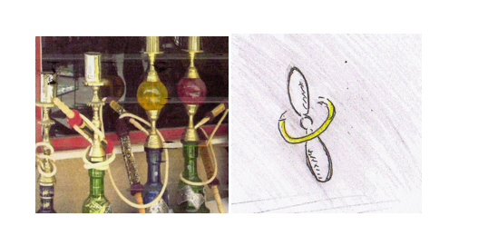
(EXHIBIT G)

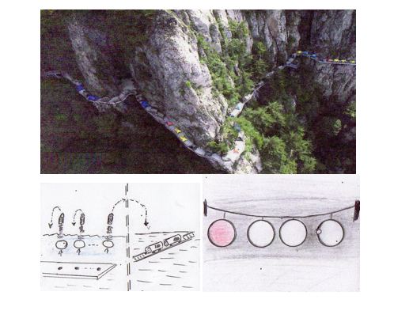
(Exhibit H)

Description: “small railroad cars in line on a narrow track”.
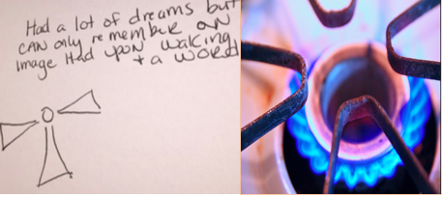
(Exhibit I)

References

Bierman, Dick. Can Psi Sponsor Itself? Simulations and Results of an Automated ARV- Casino Experiment. Presented at the 56th Parapsychological Association convention in Viterbo, Italy. 2014

Brier, R.M., A Correspondence ESP experiment with high I.Q. subjects. J. Parapsychol.,1967, 31, 143-48.

Brown, C. (2006). The Science and Theory of Nonphysical Perception, chapter 3, Farsight Press.

Buchanan, L. (2003). The Seventh Sense: The Secrets of Remote Viewing as Told by a "Psychic Spy" for the U.S. Military. Gallery Books.

Child, I.L. (1985). Psychology and Anomalous Observations: The Question of ESP in Dreams. American Psychologist, 40, 1219 – 1232.

Graff, D. E., Cyrus, P.S. (2016). Perceiving the Future News: Evidence for Retro- causation. American Institute of Physics: Quantum Retro-causation III.

Graff, D. E. (2007). "Explorations in Precognitive Dreaming". Journal of Scientific Explorations 21(4): 707-722.

Graff, D. E. (2000). River Dreams: The Case of the Missing General and Other Adventures in Psychic Research., Houghton Mifflin
Graff, D. E. (1998). Tracks in the Psychic Wilderness: An Exploration of Remote Viewing, ESP, Precognitive Dreaming, and Synchronicity., Element Books Ltd.
Harary, K. & Targ, Russell (1985). A New Approach to Forecasting Commodity Futures.” Psi Research, 4, 79-85.

Houck, Jack. (1986). Associative Remote Viewing. Archaeus, Vol 4, 31 -37.
Katz, D., Grgić, I., T.W. Fendley (2018). An Ethnographical Assessment of Project Firefly: A Yearlong Endeavor to Create Wealth by Predicting FOREX Currency Moves with Associative Remote Viewing. Journal of Scientific Exploration (Pending).
Katz, Bulgatz, McLaughlin-Walter (2017). Predicting the 2016 U.S. Presidential Election. Eight Martini’s Magazine. Issue No. 15.
Katz, Bulgatz (2013) Remote Viewing the Outcome of the 2012 Election. Aperture. Spring/Summer Issue.
Katz, D. (2008). Extraordinary Psychic: Proven Techniques to Master Your Natural Abilities. Llewellyn Publishing, M.D.
Katz, D. (2004). You Are Psychic: The Art of Clairvoyant Reading & Healing. Llewellyn Publishing, M.D.
Kolodziejzyk, Greg (2015) 13-Year Associative Remote Viewing Experiment Results. The Journal of Parapsychology. pp. 349 to 368.
Krippner, S. (1993), The Maimonides ESP-dream studies, Journal of Parapsychology, 57, pp. 39–54.

Larson, E. (1984). Did Psychic Powers Give Firm a Killing In the Silver Market? —

And Did Greed Ruin It All? Californians Switch Over To an Extrasensory Switch

Wall Street Journal. (Eastern edition). New York, N.Y.: Oct 22, 1984. pg. 1
May, E. C., Spottiswoode, J. P. , Faith, Laura V. (2000 ). A Correlation of the Gradient of Shannon Entropy and Anomalous Cognition: Toward an AC Sensory System.” Journal of Scientific Exploration, Vol. 14, No. 1, pp. 53-72.
May, E., Utts, J. Humprhrey, B., Luke, W. Frivold, T., Trask, V. (1990). Advances in Remote Viewing Analysis. Journal of Parapsychology, Vol. 54, Sept. 1990.

May, E. Two Protocols for Data Collection and Analysis. Laboratories for Fundamental Research, Palo Alto, CA. 2006
Morehouse, D. (1996). Psychic Warrior: Inside the Cia's Stargate Program : The True Story of a Soldier's Espionage and Awakening. St Martins Press.
Knowles, Jon (2017). Remote Viewing from the Ground Up. Paperback – June 13, 2017. Create Space.
Krippner, S. (1993). "The Maimonides ESP-Dream Studies." Journal of Parapsychology 57(1).
Nobel, Jon (Natural Remote Viewing: A practical guide to the mental martial art of self- discovery by Jon Noble (Create Space).

Puthoff, H. E. (1984) ARV Applications. Research in Parapsychology, 1984, Scarecrow

Press, Inc., Metuchen, NJ. pp. 121-122.
Puthoff, H., & Targ, R. A Perceptual Channel for Information over Kilometer Distances: Historical Perspective and Recent Research. Proceedings of the IEEE, Vol. 64, No. 3, March 1976.
Rosenblatt, R., Knowles, J. , Poquiz A. (2015). Applied Precognition Project (APP) and a Summary of APP-2014. Connections Through Time Issue 38: April 2015 - March 2016
Rosenblatt, M. (2000) Applications: AVM Precognition Project: Summary of Results for Protocol-1. Connections Through Time - Issue 7: April - June 2000

Targ, R., Kantra, J., Brown, D., & Wiegand, W. (1995). Viewing the Future: A Pilot Study with an Error-detecting Protocol. Journal of Scientific Exploration, 9, 367- 380.
Targ, R. (2012) The Reality of ESP: A Physicist’s Proof of Psychic Abilities. Wheaton, IL. Quest Books.
Targ, R., Puttoff, H. (2005). Mind-Reach: Scientists Look at Psychic Abilities (Studies in Consciousness). Hampton Roads Publishing.

Schwartz, Stephan A. (2007). Opening to the Infinite: The Art and Science of

Nonlocal Awareness. Nemoseen Media: Langley, Washington.
Schwartz, Stephan A. Through Time and Space: The evidence for Remote Viewing in Evidence for Psi. ed. Damien Broderick and Ben Goertzel McFarland Jefferson, N.C. 2015. pg. 44 and pp. 204-209.
Schwartz, Stephan A. Two Application-Oriented Experiments Employing a Submarine Involving a Novel Remote Viewing Protocol, One Testing the ELF Hypothesis. Invited paper. The Philosophical Research Society Conference on Extraordinary Human Functioning August 1977. Invited Paper. Annual Meetings of the Southwestern Anthropology Association/ the Association for Transpersonal Anthropology, March 1978. Parapsychological Association Annual Meetings, 1978. Invited Paper for Proceedings American Society for Psychical Research, November 1979.
Sherwood, S., & Roe, Chris (2003), A Review of Dream ESP Studies Conducted Since the Maimonides Dram ESP Programme’.

Smith, P.H. (2015). The Essential Guide to Remote Viewing: The Secret Military Remote Perception Skill Anyone Can Learn. International Press.
Smith, C., Laham, D., & Moddell, G. (2014). Stock Market Prediction Using Associative Remote Viewing by Inexperienced Viewers. Journal of Scientific Exploration, Vol. 28., No. 1., pp. 7-16, 2014.
Smith, P. H. (2005). Reading the Enemy’s Mind: Inside Star Gate—America’s Psychic Espionage Program. NY: Tom Dougherty.
Smith, Paul. (1998). Coordinate Remote Viewing Manual, Stanford Research Institute International. Available courtesy of Daz Smith via http://www.remoteviewed.com/files/CRV%20manual%20full.pdf.
Smith, Paul H., ed. (1986). Coordinate Remote Viewing. Washington, DC: Defense Intelligence Agency.(Accessible at http://rviewer.com/crvmanual/index.html ).
Swann, Ingo (1993). On Remote Viewing, UFO’s and Extraterrestrials. Fate Magazine. September, 1993. pp 73 to 82.
Lance Storm, Simon J. Sherwood, Chris A. Roe, Patrizio E. Tressoldi, Adam J. Rock, and Lorenzo Di Risio (2017). On the correspondence between dream content and target material under laboratory conditions: A meta-analysis of dream-ESP studies, 1966-2016, International Journal of Dream Research, 2017, 10, 120-140
Thouless, R.H., Brier, R. M. The Stacking Effect & Methods of Correcting For It. The Journal of Parapsychology; Jun1. 1790; 34, 2; ProQuest pg. 124
Utts, Jessica. (1996). An Assessment of the Evidence for Psychic Functioning. Journal of Scientific Exploration, Vol. 10, No. 1, pp. 3-30, 1996 .

Utts, J. M. (1988). Successful Replication vs. Statistical Significance. JP, 52, 305 – 320; 3).
Williams, L.V.; Siegel, D.S. (2014). The Oxford Handbook of the Economics of Gambling. Oxford Handbooks in Economics Series. OUP USA. p. 205

DESIGN TEAM BIO’S & CONTACT INFO

Design Team Members: Debra Katz, Nancy Smith, Michelle Bulgatz.
Project Manager/Rater/Lead Researcher: Nancy Smith.
Dreamers : Dale Graff, Marty Rosenblatt,
Dave Silverstein, Sam Smith, , Michelle Bulgatz, Debra Katz.
Target Selection Team Members: Jon Knowles, Alexis Poquiz, Igor Grgic, Mark Samuelson.
Statistician James Lane, Ph.D.
Dream Consultant Dale Graff
Proposal Review Team Rhine Research Center

The Applied Precognition Project is a highly active social based organization devoted to the exploration and use of Associative Remote Viewing. It was founded and is run by Marty Rosenblatt who organizes conferences, webinars and hosts/moderates highly active social media lists allowing for the low to no cost participation of all remote viewing enthusiasts. At any given time multiple groups are running projects, some run under Rosenblatt’s supervision but many operate independently under other now experienced group managers. www.appliedprecog.com. The Sublime group started under APP’s umbrella and then moved to be an independent group.
This is customary in applied ARV projects given that a pass could be called for a number of reasons, such as inadequate/insufficient information within dreamer’s transcripts, not enough dreamers available to participant for a trail already set up, photo sets being too similar for judges to distinguish between, too high of scores for both photos, and other breakdowns in the protocol itself such as miscommunications, errors, game cancellations, etc. (There is a formula for issuing predictions vs. passes that will be shared later. In this paper, suffice it to say here, passes are considered a protective message guarding against the loss of income and project managers are trained that passes are a project managers “best friend”, rather than as something to avoid in order to complete the needed trials in a timely manner).
There is precedence in the history of RV/Parapsychology for this and separation of roles is also a standard in many scientific studies. Charles Tart sometimes served as a viewer in his own studies (Targ; & Tart, C., ‘Pure Clairvoyance & The Necessity of Feedback’. Journal of the Society for Psychical Research, 1985, 79,485-492).
If a chosen game was cancelled after the selection had been made and the viewers were tasked, the trial will be a “scratch”, meaning it will be vacated and will not count in the overall statistics. If the game outcome is a “push” (the total score is neither over or under) this will be considered a scratch as well.
Some of the dreamers reported occasionally being uncertain as to whether information came in while asleep or just upon awakening. If they weren’t sure if it was a dream or not they could submit the information. However, if they knew they had obtained the information through conscious remote viewing related activities they were encouraged to not send this information in.
This was done again, in keeping in alignment with applied projects where some viewers participate in order to receive a prediction they can personally wager on. (This practice also ensured that there was widely distributed evidence of the predictions to eliminate the possibility of intentional cheating or errors in reporting them). While the projects designers debated as to whether to allow the dreamers to receive predictions (concerned this could lead to displacing on the photo associated with the prediction if it differed from the outcome) , it was decided that essentially those receiving the predictions would be seen as belonging to an experimental group called “receipt of predictions group” with those not, essentially being in a control group. Those who received predictions were asked to keep track of their personal wagering behaviors. Only one subsequently reported wagering once or twice at the onset of the project and then not doing so as things progressed. No trends could be found in the hit/miss ratios when comparing viewers who received predictions vs. those who did not.

