THIS TARGET WAS ASSIGNED BY JEFF RICHARDS. FRONTLOADING WAS IT WOULD BE A REAL LOCATION. IT WAS ASSIGNED ON 11-15-14.

FEEDBACK WAS GIVEN on 11-16-14, a few hours after I turned in the session.

First feedback was the target was “It’s a Small World” exhibit at Disney Land, in Calfornia. He then sent these two photos:
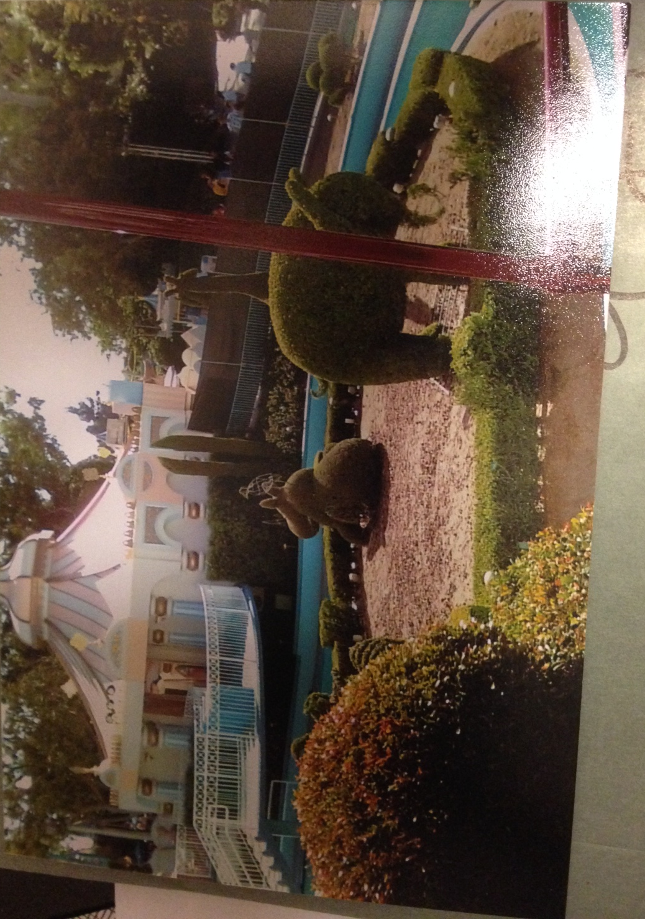

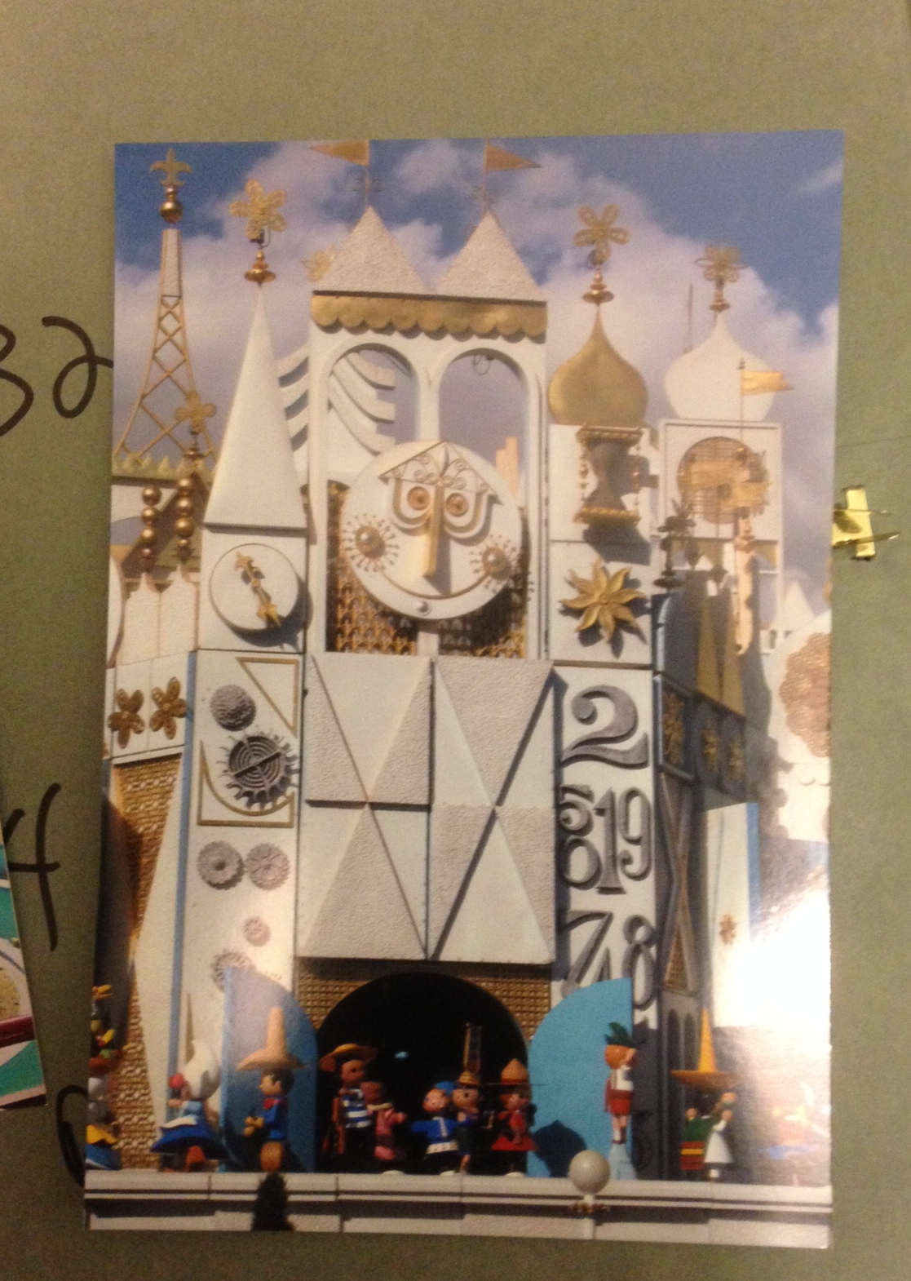

I also found this one myself online of the front of the building:
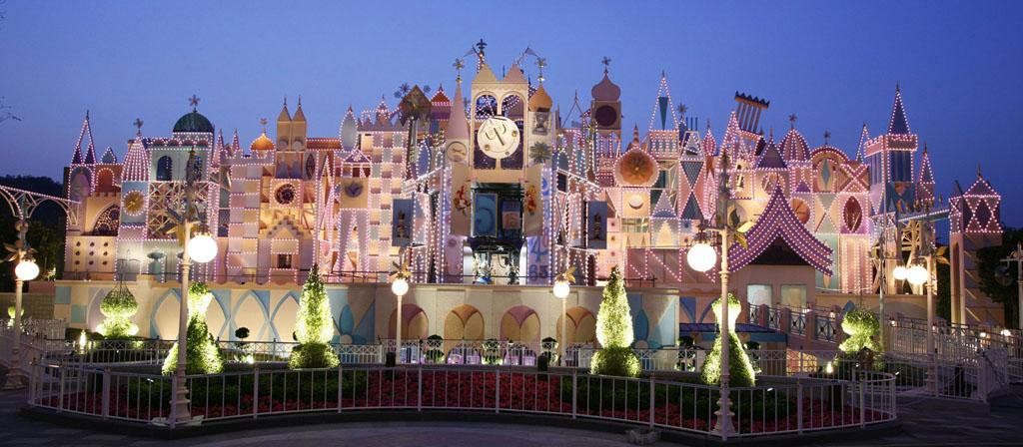

Target Number: 1147329
Viewer: Debra Katz
Tasking/frontloading Describe location and aspects that are noticeable.
Date of Session: 11-16-14
Time of Session: 11:35 pm to 12: 57 am (not including typing of summary)
Time of Summary writing
and sketch redrawing: 1.5 hours.
Location Session Performed: Living room, Phelan, CA.

The following is Target Location Overall (not just what is in any feedback photo)
What I’m going to be describing here has to be way more then just what is in any single picture.:

Emotional Ambiance was overwhelmingly powerfully positive – like this just seems like such a wonderful special place that people love so much and It’s a combination of the place itself, and the people that were there, and the experience that Jeff was having. I don’t think the place itself is necessarily overtly meant to be that spiritual, but the way that the people and their appreciation for each other, at least as far as Jeff and the people he was with related to one another, had a sense of sacredness and profoundness to it and I feel like the different enclaves of people did there bring some of this with them. The sense was there were so many people, all ages, different sizes and shapes and they were in their own little groupings of who they came with but then there was a spirit of comradeship that just permeates the whole area and maybe it’s just that people are genuinely happy to come here, and this made me feel happy and it actually helped me to relax into this target because for some reason Jeff’s initial request to do any target was making me really anxious but as soon as I started on this I relaxed. In fact for some reason I feel like I was invited to peer into a window of some special and personal moments here and it’s an honor and that was the last thing I was expecting. I feel like I can feel the special connection between Jeff and the people he loves.

I do feel like either Jeff’s mother or a mother type figure may have been present at the time my attention was directed here..

My attention was focused outdoors.

Seems like a town within a town or larger area and the two are connected
Atmosphere is festive, maybe even kind of a festival going on here or a place that is festive like.
Overall covers a large, sprawling area
Has manmade structures, buildings biological, land elements with highs and lows, walkways, water off in distance, transportation devices, signs, food and fun things like ice cream.
Has a lot going on in it.
There is a focus on family
A lot of people come here of all ages, kids are whining a bit, wanting a lot of things there.
People have cameras, lots, like some have two cameras hanging around their neck!
A lot of kids, even at least a baby
Can’t really over estimate the people
Seems like a place with so many different things going on.
Food, restaurants, eating, eateries are important here
This place seems to have artistic sculptures, flowers, etc. Unique art and creations.
I think I saw a guy playing a violin or some kind of instrument.
This is an amusing, fun, family place
Public restrooms you can access from outside. When you come out of a narrow passageway you have these large walls.
I was getting this is like a park of some kind with outside but maybe inside areas too, not sure if the inside areas are just restaurants, there are eateries around.
There are some green spots of grass maintained well like at a golf course
There seems to be a feeling of fish not too far away, water community.
Seems like water ambiance with sea side or shore or something is around, but I’m not sure how close the water is right now, maybe at a different elevation, this town seems to sit on the edge of a shoreline.

This seems like a special place that is festive. So many different things going on,
Seems artistic – harmony, dancing (native girl?) sculptures, music
There are public restrooms up on top too where I see a guy peeing.
There is a little girl running down this incline, she looks small like you can see her diapers and she may be carrying a balloon.
The kids are very high strung here and are hell bent on playing.
This feels like a family outing place

In Photo:
There is a horizontal railing with vertical slats – you may be able to see rooftops from looking over the railing some what at a distance away – rooftops that have wide slanted roofs
A building has a Bavarian look to it, in that there are brown wooded cross beams
People can lean on and they pose in front of.
Behind them is a zig sagging walkway that goes down pretty far – which makes me think the whole area has highs and lows, different elevations so if you were standing here you could look down and see rooftops towards the right, down, and beyond that some water?. I feel like a photographer is up higher seeing roof tops below and a vast area. Is this just about the place where the people are with different elevations? I think the landscape does this and the people and buildings are built into that landscape of some different elevations.
So they are up higher and they will need to walk down a walk way behind at least and wheel chairs and strollers could go down this walk way ramp. l
This is not far from a restaurant
I believe behind them is a body of water that may not be in the photo but seems there
There is sand too with some driftwood like a shore
I hear the motto over and over again as if it keeps playing “come here for the sun”
Salty sense
Sea Mammals (unless some dogs are in the water?)
But the water may not at all be in the photo with the railing but it’s down below
Kids could play in the water

Someone here has a bare midriff – like you can see a belly button so they are wearing an outfit where you can see their tummy. A women seemed to remind me of a hula dancer but maybe I’m just confusing the outfit as she had on this skirt and you could see her tummy. Her skirt, and the skirt of the stage, and even the vertical lines of the railing some people are standing up in front of an leaning at elbow level against.

I had a sense of mom, maybe Jeff’s mom is here? There is a women that reminded me of one of my friend’s Jewish mom. Mom came up even at the start of the session when I was least expecting it. Is this Jeff’s mom?
I’m seeing a guy with an earring. He is gesturing something about his wallet and I’m reminded of an orange wallet my brother has – not sure if this is saying his wallet is orange or I’m just reminded of a wallet. Some focus is on money?
Also I have a Christian ambiance around him.
I have a feeling like this is a special place and day and that it’s somehow an honor to be viewing this. Like the people involved have a deep respect for one another.
Did I mention the guy just has the most expressive

Something just seems perfect about this day. The energy is so high and there is love and a spiritual sense of things that brings tears to my eyes for some reason.
While I’ve viewed plenty of places that had multiple things going on at the locations and that were vast, I’ve never had such a feeling of so much laughter around and a sense of a sacredness hear, and it some how feels like an honor.

Not sure if people get married in this place, there may be some people that resemble brides around. When I asked are people getting married here I heard” this is better then getting married”

There did seem to be an area that looked like there was a stage.
I say it seemed like a stage because entertainment was going on the stage and people were standing near the stage but below it and then there seemed like there was red shiny tin foil type decorative fringe (red, maybe some blue too) hanging down from the stage with a microphone and people just were laughing and seemed really delighted, making exclamations. I got an image of a clown, which I sometimes get representing entertainment but also kind of something secretive.

There is building near by that has something to do with a restaurant, or one nearby, seems to have dark green paint with some white trim and I believe horizontal Siding. (some darker orange colors may be present). It’s really quite large, with an upstairs and a downstairs and a staircase that goes around the outside, it’s like I can see it from an angel with both the back and a side view in my field of vision, and a van is parked outside it. There is a sign in the window that gets turned around depending on if they are open or closed. It’s kind of got a colonial look to it’s build. There may be a short gate you open in and out of and there is something about the top that seems a bit church like, or maybe like an old fashioned bell or something on the top. Might have a clock tower with a small balcony under it. Maybe at one point in time it could have operated as a church. There is a sign on it that seems to want the general public to come back another day and a message comes from here that “You can’t take advantage of us”. (note: Not sure where that’s coming from but…I’m falling asleep as I’m typing this and that just came in out of nowhere – that was weird.

(See my sketch of the building I was getting).

I had a sense that there is an area new by, a parking lot that just so filled with cars going every which way and people in the cars and some of the cars are more like vans too. The cars are very tightly packed but the ground seems more like sand or dirt as opposed to a neatly laid out parking lot. There is some order to it but it’s not like the kind of parking lot where spaces are all blocked off and every one stays in the lines. Cars seem to be packed in with not so much order, Cars are closer to each other and there is a convertible type car that seems like a much older classic/anique car, and some how these cars even add to part of the fun. Some cars have travel type containers on top or they feel like people have been in them traveling, with more of their own personal things in them then you might find if someone was just going from off to the office for the day.

There could be boats off a distance

The area has colorful modern art statues too.

All around it’s a beautiful day, one that people are saying they could haven’t have asked for. The area is more upscale, the kind of place I call happy land, organized and structured where people have money to spend with their families.

There are levels here, so people are higher up and they go up and down these path ways that you could even take a stroller or a wheelchair if you had to, these have sharp turns but then go straight for a while, so this tells me the land is elevated in places, hill like or more. It’s breezy.

Anything else – does seem like some people come here to take photos of their wedding or some of the people seem like newly weds. I heard the word “flash mob” and reminded of a square type area. Lots of room to walk around but then the buildings and shopping and things surround that. That’s on a hill and there are things below that and then below that. But I’m reminded of places where there are people doing independent art/performing type stuff too.

Animals – there is a women and I believe she may have a small dog on a leash like a Maltese type of dog and she seems to be connected to Jeff. I think people like to show their dogs off here. There seems to be another kind of animal. I was thinking it was a seal, but not sure at all. Heard it was a “saber tooth”, and it seemed to have whiskers and I think it’s darker colored. Seemed like there were other animals too.

I felt like I was seeing Jeff just sitting there on the ground for a few moments at one point (This would not be in any photo). He was sitting there with this attitude of simply allowing. And it seemed like this small animal approached, kind of reminded me of a rabbit. Not sure about that.

Water/Sea/fishy/ ambiance keeps coming off as being in the distance even though cant necessarily see it right in the photo.

There is something really loving about the way the main people in the photo relate to each other that stands out as special. Like people appreciating other people in a strong way. Again that sense of everything is perfect today.

I did try to ask about a feedback photo, so this is based on I’m assuming I will see one (I should have asked about that). There is a male who seems to be looking at the camera with intense eyes, a thoughtful, soul foul look.
He may be on the left with shorter person or people on the right, not sure how many people are in this photo, at least two.
Does he always have such expressive, emotion filled eyes or just in this photo?
He’s wearing Navy and tan
Maybe a Navy polo type shirt tucked neatly into tan pants
A bit of a darker or tanner complexion
note first I saw this as an adult looking towards camera,
but later seemed to see an image of a kid wearing a navy shirt and looking toward the left so not sure

Something about a male, he is responsible, ethically and a really decent person.

When I ask about this places history I had an image of a canyon, like maybe canyons were used here in the day. Also Native Indians not too far away. This came up as the ambiance of native people and then I seemed to see the spirit of one guy as he would have been dressed in authentic native costume (like Native Americans – Do you call them native Canadians in Canada? Never thought of that before!).
I was trying to get a sense of where it is and heard “central”

Also when I telepathically asked Jeff about this, he stated something like, “this is where I was born”. So I’m not sure if that’s a spiritual birth or a physical birth.

Note: For some reason I want to keep calling Jeff “Mark” when describing this session.

People just love it here!

See sketches:

(Note: I believe that my sketch A may be totally reversed. Sketch A may be what you’d see if you looked over the balcony where people are in one photo, I feel like my sketch is the completely opposite perspective of what one would see (unless I was just viewing it from behind) I drew it from the opposite perspective of how I saw it so one of these is off. If the drawing is off that means I started up on the balcony. I then walked down the walkway and then further off in the distance saw these buildings that had some Bavarian type wood beems and further down may be water, and there are trees around too. So what I intended to draw was to make the balcony large in the foreground and what was below it large but I didn’t if that makes sense. I’ve been trying to draw form the perspective I want, but I can’t.

